|  |  |
| --- | --- |
|  | International Inc.  ACS |
| **ACS ODS in Snowflake**  **Installation Guide** | |
| Subject: | ACSODS in Snowflake Installation Guide |
| Version: | 1.0 |
| Last Saved Date: | 9/29/2020 3:23:03 PM |
| Brief Description: | . |

# 

|  |
| --- |
| Copyright 2020, Mitchell International. All Rights Reserved  This document contains confidential and trade secret information of Mitchell International, Inc. Mitchell International, Inc. has prepared this document for use by its internal personnel in developing new software and hardware products. Any unauthorized use or disclosure of the information herein is prohibited, and the information may not be reproduced, copied, or used in whole or in part without the prior written approval of Mitchell International, Inc. |

**Table of Contents**

Revision History 3

1. ACS ODS in snowflake versions 4

2. Admin Database Deployment in MS SQL Server 4

2.1 SQL Server Database Objects 4

2.2 SQL Server Agent Jobs 4

2.2.1 Full extraction Job 4

2.2.2 Incremental extraction Job 5

3. ODS Deployment in Snowflake 6

3.1 Database Objects 6

3.2 Snowflake Tasks 6

3.2.1 Task: ETL_Snowflake_Ods_Load 6

3.2.2 Task: TASK_ETL_LOG_ERRORS 6

# Revision History

|  |  |  |  |
| --- | --- | --- | --- |
| Date | Version | Author | Description |
| 8/28/2020 | 1.0 | MMP, Henry Li | Initial version. |
| 09/22/2020 | 1.1 | Fetiya Kefene | Updated the Replication Part |
| 9/23/2020 | 1.2 | Henry Li | Updated the install statement to add private link for production |

# ACS ODS in snowflake versions

As of 8/28/2020, we are going to release the following version of the ODS in snowflake:

|  |  |  |  |  |
| --- | --- | --- | --- | --- |
| **Release** | **CM #** | **CM Date** | **Build Label** | **Path to Drop Location** |
| 1.0.0.0 |  | 8/27/2020 | SCM_CSG_ODS_DP_SF_1.0RC\20200827.1 | \\cm1nt\Rel\CSG\SCM_CSG_ODS_DP_SF_1.0RC\20200827.1 |

# Admin Database Deployment in MS SQL Server

## SSIS Package

1. On Deployment server (Listener) Navigate to Integration Services Catalog

->SSISDB

1. Right click SSISDB Create Folder in SSISDB: Named **SnowFlakeReplication** or Pick a Different Name
2. Run install.bat from :$/CSG/Enterprise/Database/OperationalDataStore/Snowflake/DecisionPoint/CI/SSIS
   1. Install.bat <serverName> NT NT **SnowFlakeReplication** or name picked in step 2.

## SQL Server Database Objects

To support the generation of data extracts from ODS database, we created objects in a separate database.

The production builds for this are located here:

*\\cm1nt\Rel\CSG\SCM_CSG_ODS_DP_SF_****<Version>****RC\****<Build>****\drop\OdsDatabaseObjects*

Database deployments are done via the batch file **Install.bat**. The user deploying this code must have sysadmin rights on the SQL server.

TFS path:

**$/CSG/Enterprise/Database/OperationalDataStore/Snowflake/DecisionPoint/CI/OdsDatabaseObjects/**

*Install.bat <InstanceName> nt nt <DatabaseName>*

*eg. install.bat qsql104ntv nt nt snowflake_admin*

## SQL Server Agent Jobs

### Full extraction Job

Job Name: "SnowFlake Replication: Full Load"

Update SourceDatabase and OutputPath parameters in configuration

1) SourceDatabase name:

2) Output Path where flat files will generate along with control file. Please make sure output path ends with backslash.

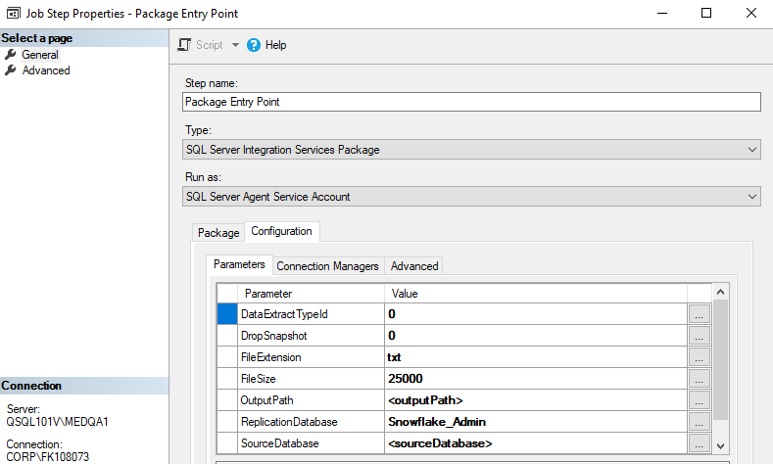

### Incremental extraction Job

Job Name: "SnowFlake Replication: Incremental Load"

Update SourceDatabase and Output Path parameters in configuration

1) SourceDatabase name:

2) Output Path where flat files will generate along with control file. Please make sure output path ends with backslash.

**Additional Parameter Details:**

**DataExtractTypeId**: Determine if extraction is full or incremental, for full load this need to set as 0.

**DropSnapshot**: Flag to control dropping of snapshot database.

Note: For now, as per discussion we decided to drop snapshots manually after data is loaded successfully to snowflake. Therefore, this parameter is set to 0 in job

Once we have enough confidence then we can set this parameter to 1. Therefore, that it will automatically drop snapshot on successful completion of extraction.

**FileExtension**: File Extension of flat data files

**FileSize**: File size threshold for splitting data

File size need to provide in MB

(For full load, we have threshold of 25GB so we have set this value to 25000)

(For incremental load, we have threshold of 400MB so we have set this value to 400)

**ReplicationDatabase**: Database name created on step 2.2, defaulted to Snowflake_Admin

**SourceServer:** server (Listener) name.

# ODS Deployment in Snowflake

## Database Objects

The snowflake ODS database stores all of the data replicated from the MS SQL ODS database.

The production builds are located here:

*\\cm1nt\Rel\CSG\SCM_CSG_ODS_DP_SF_****<Version>****RC\****<Build>****\drop\SnowFlakeDatabase*

Database deployments are done via the batch file **Install.bat**.

1. Please make sure the default browser is not IE, instead you can setup Chrome as the default.
2. Please use SSO to login and deploy.
3. Please copy all the contents within the build directory above to a folder to which you have write permission.
4. Open a command prompt.
5. Change directory to that folder and run the install.bat as below.

In the production environment*:

*Install.bat <AccountName>.privatelink <MitchellEmail> <DatabaseName> /w <DatawarehouseSize>*

*\* If it hangs during the authentication, you can press Ctrl + C to abort and try using the command for the non-production environment as below.*

In the non-production environment (e.g. QA and Dev):

*Install.bat <AccountName> <MitchellEmail> <DatabaseName> /w <DatawarehouseSize>*

## Snowflake Tasks

### Task: ETL_Snowflake_Ods_Load

In order to kick off the master stored procedure, we have scheduled a task:

* ETL_Snowflake_Ods_Load

The task currently runs every night at 6 PM Pacific Time.

### Task: TASK_ETL_LOG_ERRORS

In order to log the status of the ETL task, we have scheduled a task:

* TASK_ETL_LOG_ERRORS

The task currently runs every 10 minutes between 6 PM and 10 PM every night Pacific Time.